Object Oriented Programming

Spring 2022/2023

Sheet1 (Struct)

**Q1. Assume that you have the following definition of a struct.**

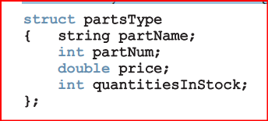

1. Declare an array, inventory, of 10 components of type partsType. Assume that the variable length indicates the number of elements in inventory.

partsType inventory[length];

1. Write a C++ code to initialize each component of inventory as follows: partName to null string, partNum to -1, price to 0.0, and quantitiesInStock to 0.

for(int i=0;i<length;i++)

{

inventory[i].partName=" ";

inventory[i].partNum=-1;

inventory[i].price=0.0;

inventory[i].quantitiesInStock=0;

}

1. Write the definition of a void function that can be used to input data in a variable of type partsType. Also write a C++ code that uses your function to input data in inventory.

void getData(partsType& pType)

{

cout<<"Enter Part Name: ";

cin >> pType.partName;

cout<<"Enter Part Number: ";

cin >> pType.partNum;

cout<<"Enter Part Price: ";

cin >> pType.price;

cout<<"Enter quantities In Stock:";

cin >> pType.quantitiesInStock;

}

for (int j = 0; j <length; j++)

getData(inventory[j]);

1. Write a function that uses a loop to output the data stored in inventory.

void print(partsType x[])

{

for(int i=0;i<length;i++)

{

cout<<"Part Name: "<<x[i].partName

<<"\nPart number: "<<x[i].partNum

<<"\nPart price: "<<x[i].price

<<"\nquantitiesInStock: "<<x[i].quantitiesInStock

<<"\n*************"<<endl;

}

}

**Q2. Suppose that you have the following definitions:**

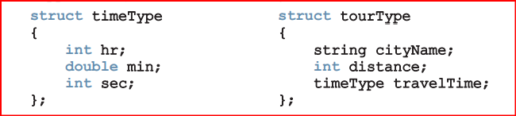

1. Declare the variable destination of type tourType.

tourType destination;

1. Write C++ statements to store the following data in destination: cityName—Chicago, distance—550 miles, travelTime—9 hours and 30 minutes.

destination.cityName = "Chicago";

destination.distance = 550;

destination.travelTime.hr = 9;

destination.travelTime.min = 30;

1. Write the definition of a function to output the data stored in a variable of type tourType.

void print(const tourType& dest)

{

cout << "City: " << dest.cityName << endl;

cout << "Distance: " << dest.distance << endl;

cout << "Travel time: " << dest.travelTime.hr << " hour(s) "

<< dest.travelTime.min << " minute(s)" << endl;

}

1. Write the definition of a value-returning function that inputs data into a variable of type tourType.

tourType getData()

{

tourType dest;

cin >> dest.cityName;

cin >> dest.distance;

cin >> dest.travelTime.hr >> dest.travelTime.min;

return dest;

}

1. Write the definition of void function with a reference parameter of type tourType to input data in a variable of type tourType.

void getData(tourType& dest)

{

cin >> dest.cityName;

cin >> dest.distance;

cin >> dest.travelTime.hr >> dest.travelTime.min;

}